LAB: 02

Name: Muhammad Waqas Siddique

Class: BSCS-ev-IV-B

Roll No: 232441

Course: Computer organization and assembly language

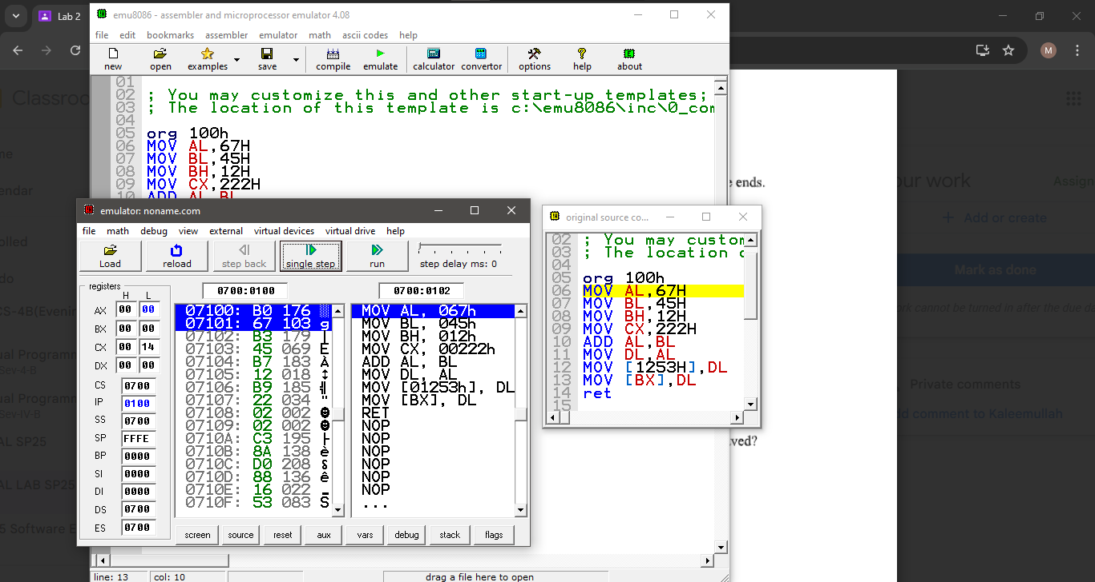

AL= 67

IP= 0102

Flags: no effect

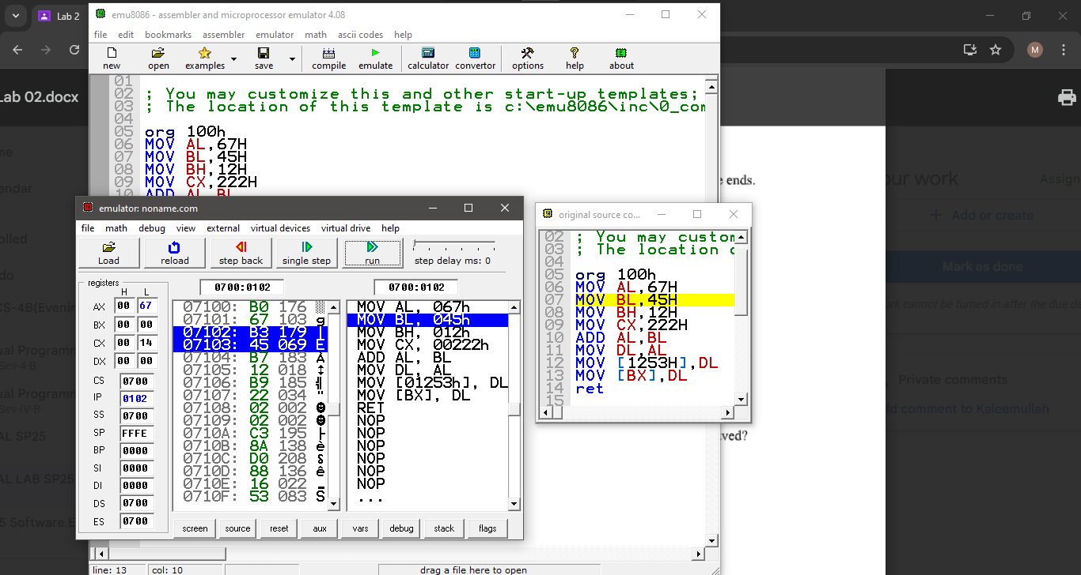

BL= 45

IP= 0104

Flags: no effect

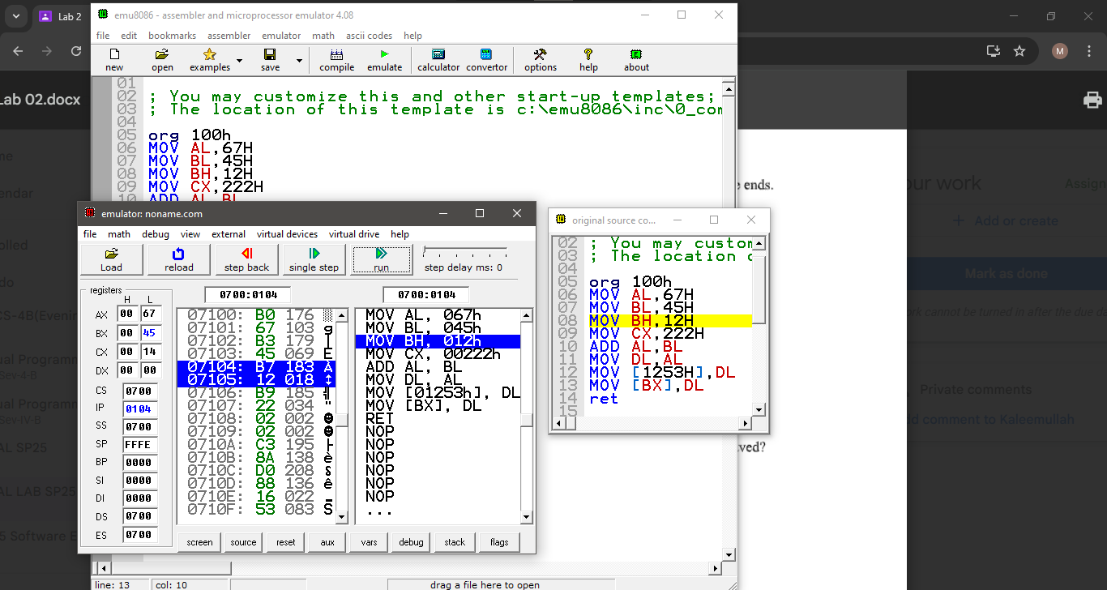

BH = 12H

No flags affected

IP= 106

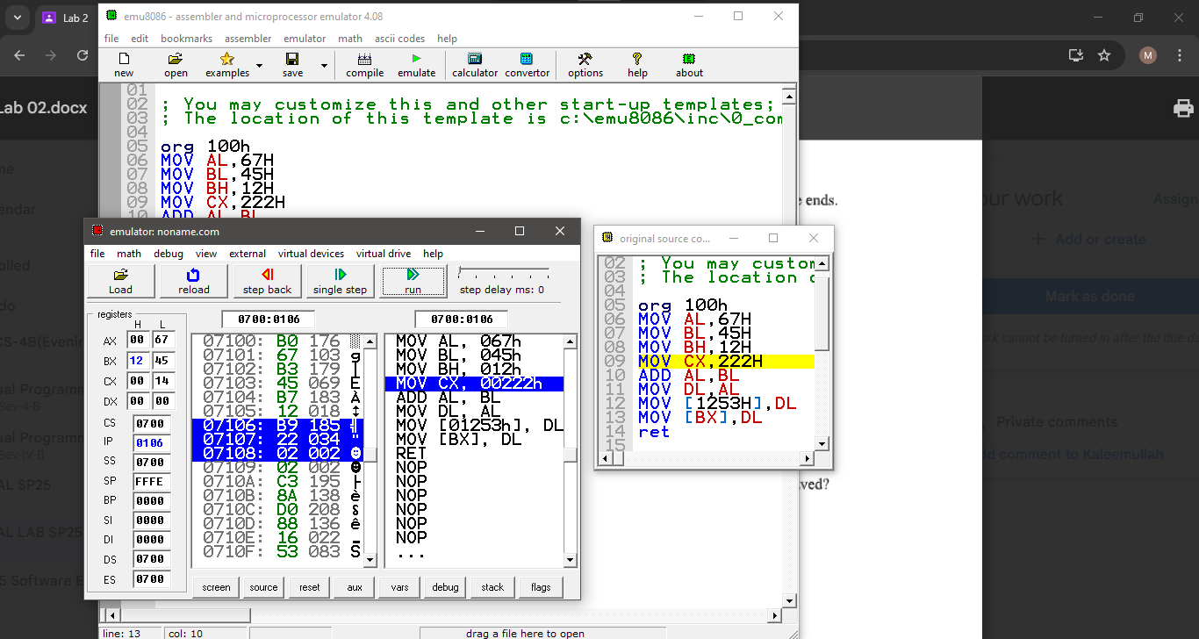

Cx=2222

IP= 109

No flag effected

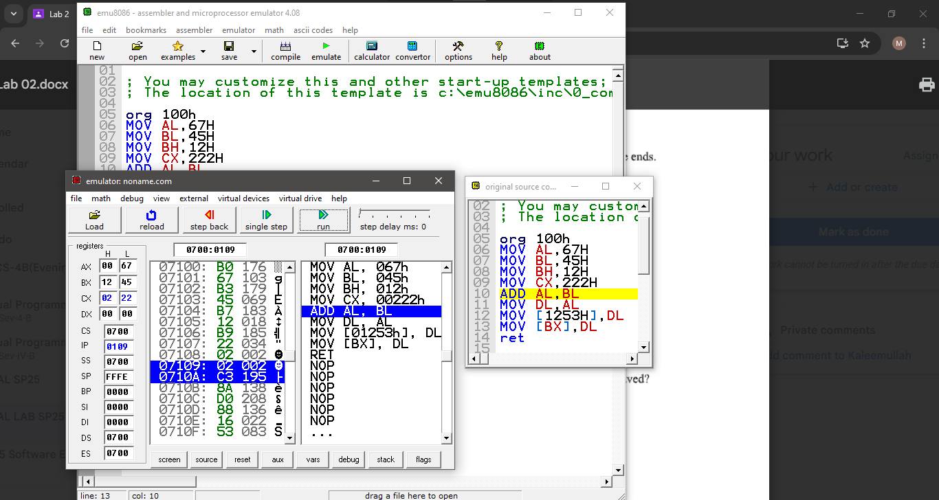

AL= AC

IP= 010B

Flags: SF=1, OP=1, PF=1, IF=1

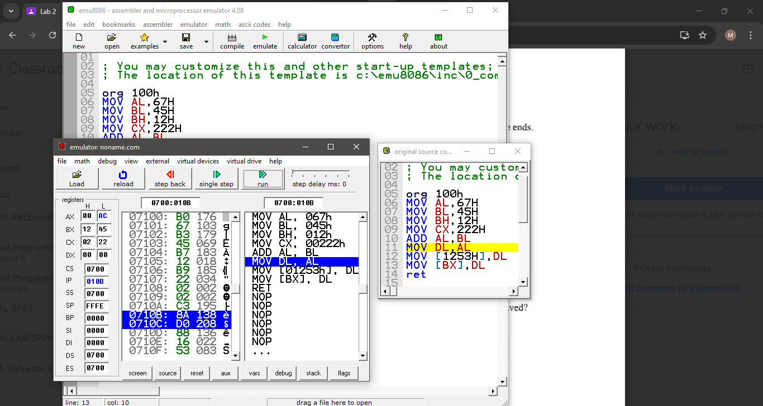

DL=AC

IP =010D

Flags: same as above

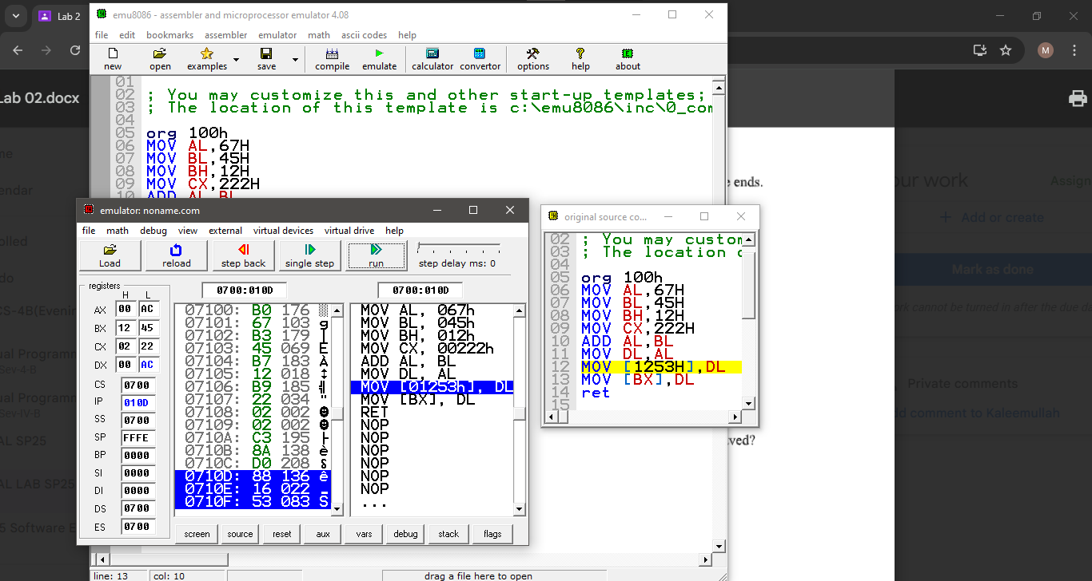

Will give the value to that specific memory location

IP= 0111

Flags= same as above

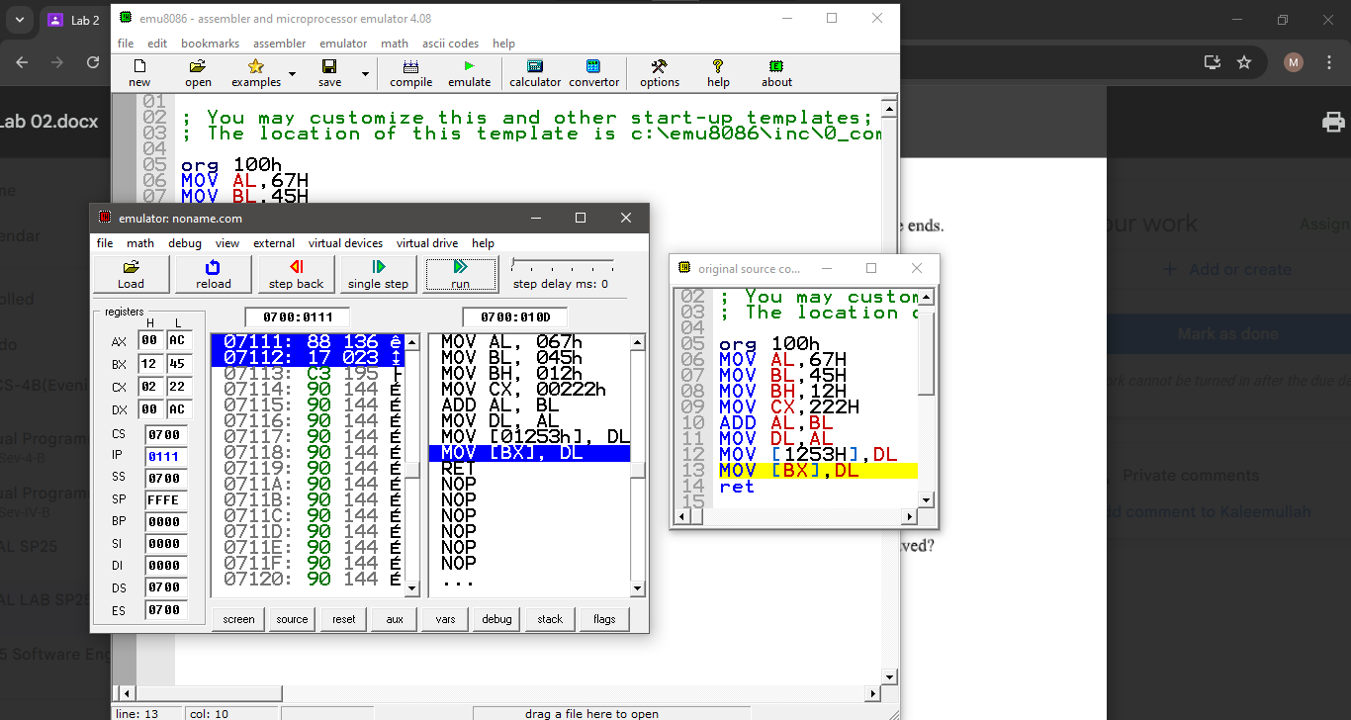

BX location will get the value of DL

IP= 0113

Flags same as above

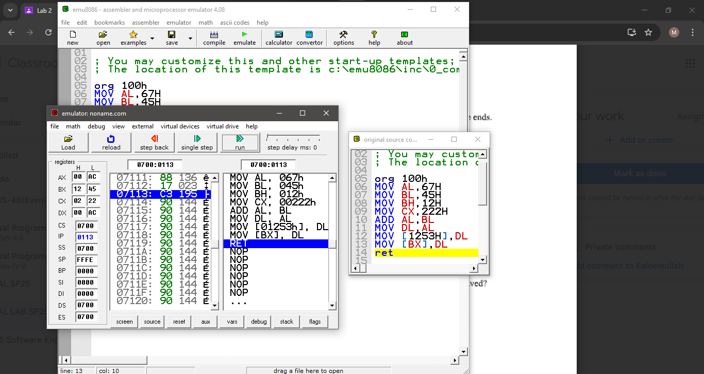

Returned control to OS